
VEL TECH HIGH TECH
Dr. RANGARAJAN Dr. SAKUNTHALA ENGINEERING COLLEGE
An Autonomous Institution

PRACTICAL IMPLEMENTATION OF QUANTUM RESISTANT ENCRYPTION USING CRYSTALS KYBER AND RSA

A MINI PROJECT REPORT
Submitted by
JYOSITHAA R T -113023104071
KALAISELVI B -113023104072
KUZHALI M -113023104083

BACHELOR OF ENGINEERING
In
COMPUTER SCIENCE AND ENGINEERING
VEL TECH HIGH TECH
Dr. RANGARAJAN Dr. SAKUNTHALA ENGINEERING COLLEGE
An Autonomous Institution

ANNA UNIVERSITY : CHENNAI 600025
NOVEMBER -2025

VEL TECH HIGH TECH
Dr. RANGARAJAN Dr. SAKUNTHALA ENGINEERING COLLEGE
An Autonomous Institution

BONAFIDE CERTIFICATE

Certified that this project entitled “Practical Implementation of Quantum resistant encryption using CRYSTALS-Kyber and RSA” is the bonafide work of Jyosithaa R T (113023104071 ), Kalaiselvi B (113023104072)
Kuzhali M (113023104083) who carried out the work under my supervision.

SIGNATURE SIGNATURE

Dr. S. Durga Devi B.E, M.E, Ph.D., Mrs. P Brinda

HEAD OF THE DEPARTMENT SUPERVISOR
Dept. Of Computer Science and Engg. Dept of Computer Science and Engg

Vel Tech High Tech Dr. Rangarajan Vel Tech High Tech Dr. Rangarajan

Dr. Sakunthala Engineering College Dr. Sakunthala Engineering College

Avadi , Chennai – 600062 Avadi , Chennai - 600062

CERTIFICATE OF EVALUATION

College Name :VEL TECH HIGH TECH DR.RANGARAJAN DR.SAKUNTHALA ENGINEERING COLLEGE
Degree : BACHELOR OF ENGINEERING
Branch :COMPUTER SCIENCE AND ENGINEERING
Semester : V

S.No. | Name of the Student(s) | Title of the Project | Name, Designation & Department of the Supervisor and Co-Supervisor
1. | JYOSITHAA R T | PRACTICAL IMPLEMENTATION OF QUANTUM RESISTANT ENCRYPTION USING CRYSTALS KYBER AND RSA | Mrs .P BRINDA  ASSISTANT PROFESSOR  COMPUTER SCIENCE AND ENGINEERING
2. | KALAISELVI B
3. | KUZHALI M

The report of the project work submitted by the above students in partial fulfilment for the award of degree, Bachelor of Technology/Engineering in _______________________________ for the viva voice examination held at Vel Tech High Tech Dr.Rangarajan Dr.Sakunthala Engineering College on __________ has been evaluated and confirmed to be reports of the work done by the above students

INTERNAL EXAMINER EXTERNAL EXAMINER

(Name, Designation and Signature with Date) (Name, Designation and Signature with Date)

ACKNOWLEDGEMENT

We wish to express our sincere thanks to the people who extended their help during the course of our project work.
First of all we would like to express our deep gratitude to our beloved and respected FOUNDER & CHAIRMAN Col. Prof. Vel. Shri. Dr. R. RANGARAJAN B.E.(Elec.), B.E (Mech.), M.S (Auto.), DSC, Foundress & VICE CHAIRMAN Dr.SAKUNTHALA RANGARAJAN M.B.B.S. and MANAGING TRUSTEE Mrs.MAHALAKSHMI KISHORE KUMAR, B.E., MBA(UK),Ph.D., for their kind encouragement and blessings.
Our deepest gratitude and thanks to our Vice President Mr.K.V.D. KISHORE KUMAR, B.E., MBA (US).We also record our sincere thanks to our Honourable Principal Dr. E. KAMALANABAN, B.E., M.E., Ph.D., for his kind support to take up this project.
We are thankful and extremely grateful to our Head of the Department Dr.S. Durga Devi B.E, M.E., (Ph.D.)., Computer Science and Engineering Department for her sustained help, guidance and inspiration in doing this project .We would like to extend our sincere thanks to our Project Coordinator, Dr. R.Kavitha ., for her continuous support for doing this project. We would like to extend our sincere thanks to our supervisor Mrs.P.Brinda , for her constant technical support and stupendous encouragement, which enabled us to complete our project successfully.

ABSTRACT

With the rapid development in quantum computing, traditional cryptographic algorithms like RSA and ECC are facing an immediate threat from quantum algorithms, such as Shor's factorization algorithm, which can efficiently break public-key systems into large integers. Based on this, the project "Practical Implementation of Quantum-Resistant Encryption using CRYSTALS-Kyber and RSA" is going to demonstrate the vulnerability of some classical encryption schemes against quantum attacks and, at the same time, implement secure post-quantum alternatives.
This project first emulates classical RSA encryption and then uses Shor's Algorithm to break it in polynomial time. Then, it deploys the lattice-based post-quantum cryptographic algorithm CRYSTALS-Kyber, selected by NIST because it resists all known quantum attacks. The proposed system lets users input a message, encrypt it using both RSA and Kyber, and compare their performance based on encryption time, key size, and security strength. The simulation and analysis results show that, while RSA is vulnerable in a quantum context, Kyber provides robust, scalable, and future-proof encryption. This comparison study underlines the need to migrate to quantum-safe cryptography in order to have secure digital communications in the upcoming quantum era. Future work may be targeted towards the integration of digital signature schemes and the development of real-time secure communication applications.

TABLE OF CONTENT

CHAPTER NO. TITLE PAGE NO.

ABSTRACT i
- INTRODUCTION - - - - - - - - - - - - - - - - - - - - - - - - - - - - - - - - - 7
1.1 Overview of Cryptography
1.2 Motivation and Problem Statement
1.3 Importance of Post-Quantum Cryptography
1.4 Objective of the Study
1.5 Scope and Applications
1.6 Organization of the Report
2. THEORETICAL BACKGROUND - - - - - - - - - - - - - - - - - - - - - 11
2.1Basics of Classical Cryptography
2.2 Classical Public-Key Cryptography (RSA)
2.3 Limitations of RSA in the Quantum Era
2.4 Overview of Quantum Computing and Shor’s Algorithm
2.5 Post-Quantum Cryptography Overview
2.6 Introduction to Lattice-Based Cryptography
3. LITERATURE SURVEYS - - - - - - - - - - - - - - - - - - - - - - - - - - - - 14
3.1 Previous Research on Quantum Attacks
3.2 Existing Post-Quantum Algorithms (Kyber, NTRU, SPHINCS+)
3.3 Comparative Study of PQC Schemes
3.4 Research Gaps Identified
4. CRYSTALS -KYBER ALGORITHM - - - - - - - - - - - - - - - - - - - -- - -- 20
4.1 Working Principle of Kyber
4.2 Mathematical Foundation (Lattice Concepts)
4.3 Key Generation, Encryption, and Decryption Process
4.4 Security Features and Strengths
4.5 Comparison of Kyber with Other PQC Schemes

5. IMPLEMENTATION METHODOLOGY - - - - - - - - - - - - 28
5.1 System requirements and tools used
5.2 Implementation of RSA Algorithm
5.3 Implementation of CRYSTALS-Kyber Algorithm
5.4 Integration of RSA and Kyber for Hybrid Encryption
5.5 Workflow Diagram and Architecture
5.6 Performance Metrics and Testing Parameters

6. RESULT - - - - - - -- - -- - - -- - - - -- - - - - - - - - - - - - - - - - - - - - - - 30
6.1 Execution Time Comparison
62 Key Size and Ciphertext Analysis
6.3 Security Evaluation
6.4 Comparison Graphs and Tables
6.5 Discussion on Practical Efficiency

7. FUTURE WORK AND CONCLUSION - - - - - - - - - - - - - - - - - - - 33

8. REFERENCES

CHAPTER I
INTRODUCTION
1.1 OVERVIEW OF CRYPTOGRAPHY :
Cryptography is the science and art of securing digital information by converting readable data, known as plaintext, into an unreadable form called ciphertext using complex mathematical algorithms. The main goal of cryptography is to ensure confidentiality, integrity, authentication, and non-repudiation of data during transmission or storage. It protects information from unauthorized access, alteration, or misuse, thereby enabling secure communication over insecure networks like the Internet. Cryptography can be broadly classified into symmetric-key cryptography and asymmetric-key cryptography. In symmetric encryption, the same secret key is used for both encryption and decryption, as seen in algorithms like AES and DES. Although efficient, symmetric encryption requires secure key sharing between parties, which can be challenging over public networks. On the other hand, asymmetric cryptography uses two mathematically related keys—a public key for encryption and a private key for decryption. Well-known examples include RSA (Rivest–Shamir–Adleman) and ECC (Elliptic Curve Cryptography), both of which form the foundation for digital signatures, SSL/TLS protocols, and secure e-commerce transactions. The strength of traditional cryptographic systems lies in the computational difficulty of solving certain mathematical problems, such as factoring large prime numbers or computing discrete logarithms. However, the emergence of quantum computing introduces a major challenge. Quantum algorithms, like Shor’s Algorithm, can perform these tasks exponentially faster, making classical encryption vulnerable to future quantum attacks. Therefore, the field of cryptography is rapidly evolving to address these risks by developing post-quantum cryptographic (PQC) systems that can withstand quantum threats. These advancements aim to preserve global digital security, ensuring that information remains safe even in the coming quantum era of computation and communication.

1.2PROBLEM STATEMENT :
The motivation behind this project comes from the potential threat posed by quantum computers, which can solve mathematical problems exponentially faster than classical systems. Algorithms such as RSA, once considered secure, can be easily broken using Shor’s Algorithm on a quantum computer. This creates a serious risk to current data security frameworks. The problem addressed here is the vulnerability of classical encryption in the quantum era and the urgent need to develop and implement quantum-resistant encryption methods that can ensure future-proof data protection for critical systems like banking, military, and healthcare.

1.3 IMPORTANCE OF POST QUANTUM CRYPTOGRAPHY :
Post-Quantum Cryptography (PQC) plays a vital role in ensuring the future security of digital communication in the presence of quantum computers. Traditional encryption systems like RSA and ECC, which depend on the computational difficulty of factoring large integers or solving discrete logarithms, are highly vulnerable to quantum algorithms such as Shor’s Algorithm. PQC, on the other hand, introduces new encryption methods based on mathematical problems that remain difficult even for quantum machines to solve efficiently.
These post-quantum algorithms include lattice-based, hash-based, code-based, and multivariate polynomial-based cryptography. Among them, lattice-based algorithms like CRYSTALS-Kyber have gained significant attention for their strong security and practical efficiency. The adoption of PQC ensures long-term digital trust, data privacy, and authentication, safeguarding sensitive information in critical sectors such as government, defense, finance, and cloud computing. As organizations prepare for the quantum era, implementing PQC is not just an option but a necessity to prevent potential data breaches and ensure global cybersecurity resilience. By transitioning to quantum-safe cryptographic standards, societies can continue to enjoy secure communication and data integrity even in the face of rapid technological evolution.

1.4 OBJECTIVE OF THE STUDY :
The key objectives of this study are:
- To simulate classical RSA encryption and evaluate its vulnerability under quantum attacks.
- To implement a quantum-resistant algorithm such as CRYSTALS-Kyber for secure communication.
- To compare encryption speed, key size, and overall security between RSA and Kyber.
- To demonstrate the need for adopting post-quantum encryption techniques in real-world systems.

1.4 SCOPE AND APPLICATIONS :

The scope of this project encompasses the implementation, analysis, and evaluation of quantum-resistant encryption algorithms to ensure data security in the emerging quantum era. The project focuses on demonstrating how traditional encryption methods, such as RSA, become vulnerable under quantum attacks and how modern post-quantum algorithms, like CRYSTALS-Kyber, provide a stronger, more secure alternative. The study includes simulating both encryption methods, comparing their performance in terms of encryption speed, key size, and security strength, and visually representing the results for better understanding. The practical applications of this project are vast and highly relevant. It can be implemented in banking systems for secure online transactions, cloud computing platforms for protected data storage, e-commerce for secure customer communication, and defense or governmental sectors to safeguard confidential information. By highlighting the advantages of post-quantum cryptography, this project aims to encourage organizations to adopt quantum-safe encryption standards before quantum computers become commercially available. Ultimately, the project contributes toward building future-proof cybersecurity systems capable of maintaining long-term data confidentiality, integrity, and reliability in an era dominated by quantum technologies.

CHAPTER II
THEORETICAL BACKGROUND

2.1 BASICS OF CLASSSICAL CRYPTOGRAPHY :

Classical cryptography refers to traditional methods of securing information by converting readable text (plaintext) into an unreadable form (ciphertext) using mathematical operations and secret keys. Its main goals are confidentiality, integrity, authentication, and non-repudiation. Classical cryptography can be broadly categorized into symmetric-key and asymmetric-key systems. In symmetric-key cryptography, the same key is used for both encryption and decryption (e.g., AES, DES), making it fast but less secure for large-scale communication due to key-sharing difficulties. In asymmetric cryptography, different keys are used—one public and one private—allowing secure communication even over untrusted networks. Algorithms like RSA and ECC have long been used to protect sensitive data in online banking, digital signatures, and secure communication systems.

2.2 CLASSICAL PUBLIC KEY CRYPTOGRAPHY (RSA):
The RSA (Rivest–Shamir–Adleman) algorithm, introduced in 1977, is one of the most fundamental and widely adopted public-key cryptographic systems used for secure data transmission. It is based on the mathematical concept of integer factorization, which involves finding the two large prime numbers that multiply to form a large composite number. The strength of RSA lies in the computational difficulty of this factorization process, which makes it nearly impossible for attackers using classical computers to derive the private key from the public key. RSA operates through three essential stages: key generation, encryption, and decryption. During key generation, a public key and a private key are created — the public key is shared openly to encrypt data, while the private key remains confidential for decryption. The algorithm ensures data confidentiality and authentication, making it a cornerstone of digital signatures, secure email, and online transactions. However, RSA’s efficiency and security depend on the key length. Larger key sizes provide stronger protection but reduce processing speed. Moreover, the emergence of quantum computing poses a significant threat, as algorithms like Shor’s Algorithm can factor large numbers efficiently, potentially compromising RSA encryption and exposing sensitive information.

2.3 LIMITATIONS OF RSA IN QUANTUM ERA :

RSA’s security depends on the infeasibility of prime factorization using classical computers. However, the advent of quantum computing introduces algorithms that can perform this task exponentially faster. The most significant threat is Shor’s Algorithm, which can factor large integers and compute discrete logarithms efficiently using quantum properties like superposition and entanglement. This means that encryption keys once considered unbreakable could be compromised within seconds by a quantum computer. Consequently, RSA and similar algorithms (such as ECC) are no longer sufficient to protect sensitive data in the quantum age. This limitation has driven the need for Post-Quantum Cryptography (PQC) — cryptographic systems that remain secure against both classical and quantum attacks.

2.4 OVERVIEW OF QUANTUM COMPUTING AND SHOR’S ALGORITHM :
Quantum computing is a revolutionary technology based on the principles of quantum mechanics, using qubits instead of classical bits. Unlike bits, which can represent only 0 or 1, qubits can exist in multiple states simultaneously due to superposition, and can influence each other through entanglement, enabling parallel computation. This gives quantum computers extraordinary processing power for solving complex problems. Shor’s Algorithm, developed by Peter Shor in 1994, is one of the most important quantum algorithms. It can factor large numbers and compute discrete logarithms in polynomial time, tasks that would take classical computers thousands of years. As a result, Shor’s Algorithm poses a serious threat to encryption methods like RSA and ECC, which depend on these hard mathematical problems for security.

2.5 POST QUANTUM CRYPTOGRAPHY OVERVIEW :
Post-Quantum Cryptography (PQC) refers to cryptographic algorithms that can withstand attacks from both classical and quantum computers. These algorithms are based on complex mathematical problems that remain hard even for quantum computation. PQC includes various approaches such as lattice-based, hash-based, code-based, and multivariate polynomial-based cryptography. The primary goal of PQC is to ensure long-term data security and future-proof encryption in a world where quantum computers could easily break traditional methods. International organizations like NIST (National Institute of Standards and Technology) are actively standardizing PQC algorithms, with CRYSTALS-Kyber emerging as a leading choice due to its efficiency, scalability, and strong resistance to quantum attacks.

2.6 INTRODUCTION TO LATTICE BASED CRYPTOGRAPHY:

Lattice-based cryptography is one of the most promising areas of post-quantum cryptography. It relies on the mathematical complexity of problems related to multi-dimensional lattices—structured grids of points in space. The hardness of solving problems such as the Shortest Vector Problem (SVP) and Learning With Errors (LWE) makes lattice-based schemes resistant to both classical and quantum attacks. Algorithms like CRYSTALS-Kyber (for encryption) and CRYSTALS-Dilithium (for digital signatures) are based on these principles. Lattice-based cryptography offers strong security, efficient key generation, and relatively small ciphertext sizes, making it suitable for practical real-world deployment. Its robustness against quantum attacks has positioned it as a cornerstone of future cryptographic standards for secure global communication.

CHAPTER III
LITERATURE SURVEY
3.1 PREVIOUS RESEARCH ON QUANTUM ATTACKS

The study of quantum attacks has evolved significantly over the past two decades, driven by the rapid progress in quantum computing technologies. Early research in the 1990s, particularly the introduction of Shor’s algorithm (1994), laid the foundation for understanding the vulnerability of classical cryptosystems such as RSA and ECC (Elliptic Curve Cryptography). Shor’s algorithm demonstrated that a sufficiently powerful quantum computer could factor large integers and compute discrete logarithms exponentially faster than the best-known classical algorithms. This discovery was pivotal, as it indicated that widely deployed encryption systems would no longer be secure once scalable quantum hardware became available.
Subsequent research expanded on the implications of Shor’s and Grover’s algorithms for various cryptographic primitives. Grover’s algorithm, introduced in 1996, showed that symmetric key cryptography could also be affected by quantum acceleration, effectively halving the key length security. For example, a 256-bit symmetric key system such as AES would offer only 128-bit security against a quantum adversary. This insight prompted the cryptographic community to begin considering post-quantum cryptography (PQC) approaches to mitigate the risk of future quantum attacks.
In the early 2000s, researchers began developing mathematical frameworks to categorize cryptographic algorithms based on their resistance to quantum attacks. Notably, Michele Mosca and others emphasized the urgency of migrating to quantum-resistant schemes, coining the concept of “quantum-safe” or “quantum-resilient” encryption. Between 2010 and 2020, numerous studies explored quantum threat models, simulating attack scenarios on existing public-key infrastructures and identifying key vulnerabilities in RSA, Diffie–Hellman, and ECC implementations.
The National Institute of Standards and Technology (NIST) initiated its Post-Quantum Cryptography Standardization Project in 2016 to systematically evaluate algorithms resilient to quantum-based attacks. This global effort inspired extensive comparative research into lattice-based, code-based, and multivariate polynomial cryptography. Among these, lattice-based cryptography emerged as a leading candidate due to its strong security proofs and practical performance. The CRYSTALS-Kyber algorithm, developed through collaborations by researchers from IBM, NXP, and other institutions, became a focal point of research for its robustness against both classical and quantum adversaries.

3.2 EXISTING POST-QUANTUM ALGORITHMS (KYBER,NTRU)

The emergence of quantum computing has accelerated the development of post-quantum cryptographic (PQC) algorithms that can resist attacks from both classical and quantum adversaries. These algorithms are built upon complex mathematical problems that remain computationally infeasible for quantum computers to solve efficiently. Among the various families of PQC schemes proposed and analyzed, Kyber, NTRU, and SPHINCS+ have gained substantial attention for their strong theoretical foundations, efficient implementation, and recognition by the National Institute of Standards and Technology (NIST) during its Post-Quantum Cryptography Standardization Project.
Kyber (CRYSTALS-Kyber)
Kyber is a lattice-based key encapsulation mechanism (KEM) belonging to the CRYSTALS (Cryptographic Suite for Algebraic Lattices) family. It relies on the Learning With Errors (LWE) problem, specifically its structured variant, the Module-LWE problem, which is believed to be resistant to quantum attacks. The primary advantage of Kyber lies in its strong security proofs and high performance on both software and hardware platforms.
Kyber’s design emphasizes compact key sizes, low latency, and high throughput, making it suitable for a wide range of real-world applications such as secure messaging, VPNs, and IoT devices. In 2022, NIST officially selected CRYSTALS-Kyber as the standard algorithm for public-key encryption and key establishment in the post-quantum era. The scheme achieves its robustness through noise-based randomization and modular arithmetic, which make it computationally infeasible for adversaries—even with quantum resources—to recover private keys or plaintexts. Furthermore, Kyber’s performance benchmarks indicate that it can be efficiently integrated into existing communication protocols such as TLS and SSH with minimal modifications.
NTRU (Nth Degree Truncated Polynomial Ring Units)
NTRU is one of the earliest lattice-based encryption systems, originally proposed in 1996 by Hoffstein, Pipher, and Silverman. Unlike Kyber, which uses the LWE problem, NTRU is based on the hardness of finding short vectors in a polynomial ring, a problem that has resisted all known classical and quantum attacks to date. The NTRU algorithm performs encryption and decryption operations within polynomial rings using convolution modular arithmetic, which ensures both efficiency and robustness.
SPHINCS+ (Stateless Hash-Based Signature Scheme)
SPHINCS+ represents a different branch of post-quantum cryptography, based on hash-based digital signatures rather than lattice or code-based systems. Introduced by Bernstein, Hülsing, Kölbl, and others, SPHINCS+ uses cryptographic hash functions as its primary building block, relying on their one-way and collision-resistant properties. The key strength of SPHINCS+ is its minimal reliance on unproven mathematical assumptions; its security is based purely on the hardness of inverting or colliding secure hash functions, which are considered resilient to quantum computation except for quadratic speed-ups via Grover’s algorithm.

3.3 COMPARITIVE STUDY OF PQC SCHEMES

A comparative evaluation of post-quantum cryptographic schemes is essential to understand their trade-offs and to select appropriate algorithms for different application contexts (e.g., TLS, IoT, long-term archival, digital signatures). PQC schemes can be grouped by their underlying hard problems: lattice-based, code-based, hash-based, multivariate, and isogeny-based. Below is a structured comparison across key dimensions: security assumptions, computational cost, key / signature / ciphertext sizes, implementation complexity, maturity, and typical application domains.
Security assumptions and resistance to quantum attacks
- Lattice-based schemes (e.g., Kyber, NTRU, Dilithium) rely on problems such as Learning With Errors (LWE), Module-LWE, and shortest/closest vector problems in lattices. These problems currently have no known efficient quantum algorithms and are considered among the most promising foundations for PQC. Security reductions to worst-case lattice problems exist for many lattice constructions, giving strong theoretical confidence.
- Code-based schemes (e.g., McEliece variants) base security on decoding random linear codes (e.g., Goppa codes). They have long-standing resistance to cryptanalysis and are conservative choices for long-term confidentiality; however, they typically require very large public keys.
- Hash-based signatures (e.g., SPHINCS+) rest on well-studied assumptions about hash function security. Their security is conservative and simple to reason about (relying only on hash properties), but they generally produce large signatures and are signature-only schemes (not for key-encapsulation).
- Multivariate schemes rely on the hardness of solving systems of multivariate quadratic equations. Some candidates have shown performance advantages for signatures, but several designs have been subject to cryptanalysis, so careful selection and parameterization are necessary.
- Isogeny-based schemes (e.g., SIKE — historical note) aimed to provide small keys via hard problems in supersingular isogeny graphs. Note: some isogeny-based constructions have experienced serious cryptanalytic progress; any deployment decision must follow the latest community guidance and standards.

3.4 RESEARCH GAPS IDENTIFIED

Despite the significant progress in the field of post-quantum cryptography (PQC) and the standardization efforts led by NIST, several critical research gaps remain that must be addressed to ensure the comprehensive and secure adoption of quantum-resistant encryption systems. The integration of algorithms like CRYSTALS-Kyber and RSA within real-world applications highlights both theoretical and practical challenges that require continued investigation.
One of the foremost research gaps lies in the optimization of performance and resource utilization in PQC algorithms. While lattice-based schemes such as Kyber offer a promising balance between security and efficiency, their computational requirements remain high for resource-constrained devices, such as embedded systems, IoT devices, and smart sensors. Implementing Kyber on low-power processors often results in latency and memory constraints, which can hinder scalability. Consequently, researchers are actively exploring lightweight implementations, hardware accelerators, and algorithmic refinements to achieve energy-efficient encryption without compromising post-quantum security.
Although many PQC schemes are based on mathematically hard problems, formal security proofs and real-world cryptanalytic evaluations are still evolving. Lattice-based algorithms, for example, rely on assumptions such as the Learning With Errors (LWE) and Module-LWE problems, which are believed to be hard for both classical and quantum adversaries. However, their long-term resistance to emerging quantum algorithms has not yet been definitively proven. Furthermore, many studies have focused primarily on theoretical security rather than analyzing side-channel vulnerabilities, fault attacks, or implementation-level weaknesses. This gap underscores the need for comprehensive cryptanalytic research to validate the robustness of these systems across various threat models.
Another prominent challenge is the lack of interoperability and standardization across PQC implementations. While NIST has selected Kyber for key encapsulation and Dilithium for digital signatures, the transition from classical to quantum-safe infrastructures remains complex. Different organizations and nations are developing their own PQC frameworks, leading to compatibility issues in protocols, key management, and certification processes. Moreover, hybrid cryptographic systems—combining RSA or ECC with Kyber—often face difficulties in synchronization and parameter alignment, raising concerns about efficiency and security trade-offs. The development of global standards for PQC integration is therefore an open research area.

CHAPTER IV
CRYSTAL-KYBER ALGORITHM

4.1 WORKING PRINCIPLE OF KYBER

The CRYSTALS-Kyber algorithm is a lattice-based key encapsulation mechanism (KEM) designed to provide strong security against both classical and quantum adversaries. It operates on the mathematical hardness of the Module Learning With Errors (Module-LWE) problem — a computationally difficult problem that forms the foundation for most lattice-based cryptographic schemes. Kyber’s efficiency, simplicity, and proven theoretical security make it one of the most suitable candidates for real-world post-quantum encryption applications.
At its core, Kyber relies on the Learning With Errors (LWE) problem, which can be described as the challenge of solving a system of linear equations that includes a small amount of random noise. More precisely, the problem involves recovering a secret vector s from given linear equations of the form.

where A is a known public matrix, b is a public vector, e represents a small error vector, and q is a predefined modulus. The presence of the error term e makes it computationally infeasible for an adversary — even one equipped with a quantum computer — to solve for s efficiently. The Module-LWE variant used in Kyber generalizes this concept by introducing structured polynomials that allow for faster computation while maintaining the same level of security.
The security of Kyber lies in the difficulty of solving the Module-LWE problem. The use of error vectors and modular arithmetic prevents attackers from using linear algebra or quantum algorithms like Shor’s algorithm to derive secret keys. Additionally, the system incorporates a key confirmation mechanism and hash-based entropy generation, which reduce the risk of key reuse and related-key attacks.
Kyber also employs IND-CCA2 (Indistinguishability under Chosen Ciphertext Attack) security, which ensures that even if an adversary can query the decryption oracle, they cannot distinguish between ciphertexts or extract meaningful information. This level of robustness makes Kyber highly resistant to active and adaptive adversaries.

4.2 MATHEMATICAL FOUNDATION (LATTICE CONCEPTS)

The mathematical foundation of quantum-resistant cryptography—particularly the CRYSTALS-Kyber algorithm—rests upon the concepts of lattice-based mathematics. Lattice-based cryptography has emerged as one of the most promising approaches for constructing secure post-quantum encryption schemes, as it relies on computational problems that remain hard even for quantum computers. This section explores the essential lattice concepts that underpin Kyber and similar post-quantum cryptographic systems.

In simpler terms, a lattice is a grid-like structure that extends infinitely in space, but only at points that can be expressed as integer combinations of its basis vectors. Each lattice can have multiple bases, and different bases can generate the same lattice even though they may look very different geometrically.
Lattices can exist in any dimension, and higher-dimensional lattices form the basis of the security mechanisms used in modern post-quantum cryptography. The regularity and structure of lattices make them suitable for constructing mathematical problems that are easy to generate but extremely difficult to solve without specific secret information.
The security of lattice-based cryptographic systems like Kyber is based on certain computational problems that are mathematically hard, even for quantum algorithms. The two most important hard problems are:
(a) Shortest Vector Problem (SVP)
Given a lattice , the Shortest Vector Problem asks for the non-zero vector with the smallest possible Euclidean norm:

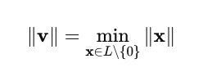

Finding the shortest vector is computationally infeasible for high-dimensional lattices because the number of possible vectors increases exponentially with dimension. This difficulty ensures that even if an attacker has access to the lattice basis, determining the shortest vector (which could represent a secret key) is nearly impossible.
Lattice-based cryptography provides several mathematical and practical advantages:
- Quantum Resistance: The underlying problems are not susceptible to quantum algorithms like those used to break RSA and ECC.
- Provable Security: The hardness assumptions can be mathematically reduced to well-studied lattice problems, providing formal proofs of security.
- Efficiency: Operations such as addition, multiplication, and sampling can be implemented efficiently using structured polynomials.
- Versatility: Lattice-based schemes support a wide range of cryptographic primitives including encryption, digital signatures, and homomorphic encryption.

4.3 KEY GENERATION, ENCRYPTION,AND DECRYPTION PROCESS

The CRYSTALS-Kyber algorithm functions as a Key Encapsulation Mechanism (KEM), designed to provide secure key exchange between two communicating parties over an insecure channel. Unlike traditional encryption schemes, Kyber does not directly encrypt plaintext messages; instead, it facilitates the secure generation and exchange of a shared secret key, which can then be used for symmetric encryption (such as AES). The strength of Kyber lies in its structured lattice-based mathematics and Learning With Errors (LWE) principle, which ensure resistance to both classical and quantum attacks.

This section describes in detail the three main stages of Kyber’s operation—key generation, encryption (encapsulation), and decryption (decapsulation)—highlighting the underlying mathematical principles and cryptographic mechanisms.
The key generation phase is the foundation of Kyber’s secure communication process. It involves generating a pair of keys: a public key (used for encryption by the sender) and a private key (used for decryption by the receiver).
Step 1: Parameter Initialization
The algorithm begins by defining essential parameters, including:
- The modulus ,which determines the finite field for arithmetic operations.
- The dimension of the polynomial ring.
- Security level (Kyber512, Kyber768, or Kyber1024), which defines key sizes and noise distributions.
Each level corresponds to different security strengths — Kyber512 for general use, Kyber768 for medium security, and Kyber1024 for high-security applications.
Step 2: Seed Generation
Two random seeds are generated:
- SeedA: Used to deterministically generate the public matrix.
- SeedR: Used to generate small random noise vectors from a discrete Gaussian or centered binomial distribution.

Kyber incorporates several cryptographic safeguards during key generation and data transmission:
- Noise Addition: Random noise vectors prevent linear algebraic recovery of secrets.
- Hash-Based Entropy: Hash functions introduce randomness, ensuring unpredictability in key derivation.
- IND-CCA2 Security: Kyber achieves indistinguishability under chosen ciphertext attack, ensuring that even adaptive adversaries cannot derive useful information.
- Error Checking: Integrity verification during decapsulation protects against modification or replay attacks.
These features ensure that Kyber maintains robust security even under active and quantum adversarial models.

4.4 SECURITY FEATURES AND STRENGTHS

The CRYSTALS-Kyber algorithm represents one of the most robust and efficient post-quantum cryptographic (PQC) schemes, designed to withstand the threats posed by emerging quantum computing technologies. Its security is based on the mathematical hardness of the Module Learning With Errors (Module-LWE) problem, which ensures that even a quantum computer cannot efficiently reverse-engineer secret keys or decrypt ciphertexts.
Unlike traditional public-key algorithms such as RSA or Elliptic Curve Cryptography (ECC), whose security is derived from integer factorization and discrete logarithm problems (both of which are vulnerable to Shor’s algorithm), Kyber’s design leverages lattice-based mathematics that remain computationally intractable even for quantum systems. This section explores the security features and strengths that make CRYSTALS-Kyber a cornerstone of modern post-quantum encryption.

One of the most critical advantages of Kyber is its quantum resistance. Traditional algorithms like RSA and ECC rely on problems that can be solved efficiently using quantum algorithms, leading to the eventual obsolescence of these schemes in a quantum era.
Kyber, on the other hand, is built upon the Module-LWE problem, which has no known polynomial-time quantum solution. The problem involves recovering a secret vector from a noisy system of linear equations—a task that remains computationally infeasible even for quantum computers.
Furthermore, Kyber’s underlying lattice problems scale exponentially in difficulty as dimensions increase, ensuring that any brute-force or quantum-assisted attack would require an impractically large amount of computational resources and time.

Kyber provides IND-CCA2 (Indistinguishability under Adaptive Chosen Ciphertext Attack) security, one of the highest security levels achievable in public-key encryption. This means that even if an attacker can query a decryption oracle with chosen ciphertexts, they will not be able to gain any information about the corresponding plaintexts or the secret keys.
This feature is achieved through the Fujisaki–Okamoto (FO) transformation, which converts a basic Key Encapsulation Mechanism (KEM) into a secure one. In Kyber, this transformation integrates hashing, re-encryption, and verification processes that ensure that any manipulated ciphertext is immediately detected and rejected during decapsulation.
Thus, Kyber is protected against sophisticated attacks that exploit decryption interfaces, a crucial requirement for real-world cryptographic applications.

4.5 COMAPARISON OF KYBER WITH OTHER PQC SCHEMES

The emergence of quantum computing has led to a paradigm shift in cryptography, necessitating the development of Post-Quantum Cryptographic (PQC) algorithms that remain secure against both classical and quantum attacks. Among these, CRYSTALS-Kyber has gained significant attention for its balance of security, efficiency, and practicality, making it one of the leading candidates for widespread adoption. However, several other PQC schemes—such as NTRU, SABER, and SPHINCS+—also offer strong post-quantum security based on different mathematical assumptions.
This section presents a comprehensive comparative analysis of Kyber with other major PQC schemes in terms of their mathematical foundations, performance, key sizes, computational efficiency, and security levels.
PQC algorithms can be broadly categorized into several families, each based on distinct mathematical problems that are believed to be hard for quantum computers to solve:
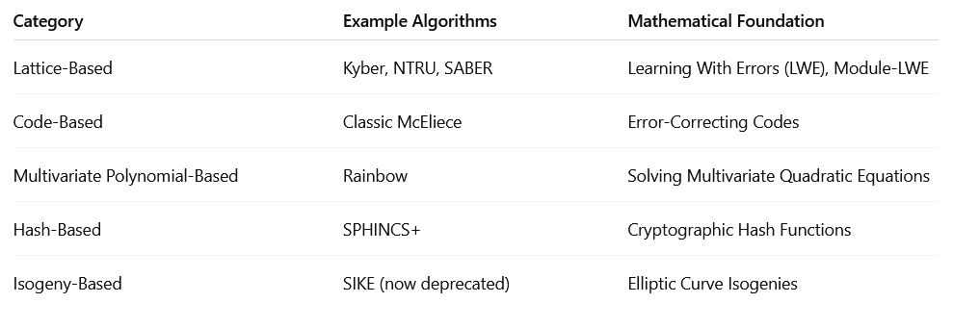

In conclusion, CRYSTALS-Kyber stands out among post-quantum encryption schemes for its balanced combination of security, efficiency, and scalability. Compared to other PQC algorithms:
- It provides smaller key sizes than code-based systems like McEliece.
- It offers better performance and simpler implementation than SABER and NTRU.
- It complements signature schemes like SPHINCS+ in hybrid cryptographic infrastructures.
Kyber’s formal security proofs, IND-CCA2 resistance, and efficient lattice arithmetic make it the most practical and widely endorsed PQC encryption standard for the post-quantum era. Consequently, it has been officially selected by NIST (National Institute of Standards and Technology) for standardization, marking a significant milestone in the global transition toward quantum-safe communication systems.
The emergence of quantum computing has posed a serious threat to the foundations of classical public-key cryptography such as RSA and Elliptic Curve Cryptography (ECC). These systems rely on mathematical problems such as integer factorization and discrete logarithms, which can be efficiently solved by quantum algorithms like Shor’s algorithm. This potential vulnerability has motivated the development of Post-Quantum Cryptographic (PQC) algorithms that remain secure against both classical and quantum computational attacks. Among the many proposed schemes, CRYSTALS-Kyber has gained significant attention due to its strong security foundation, computational efficiency, and suitability for real-world deployment.
Post-quantum cryptographic schemes are designed using mathematical problems that are believed to be resistant to quantum computation. The main families of PQC schemes include lattice-based, code-based, multivariate polynomial, hash-based, and isogeny-based cryptography.

CHAPTER V
IMPLEMENTATION METHODOLOGY

5.1 SYSTEM REQUIREMENTS AND TOOLS USED

The successful implementation and evaluation of any cryptographic algorithm, especially a post-quantum encryption system like CRYSTALS-Kyber integrated with RSA, require a well-defined computational environment and a set of supporting tools. The purpose of defining system requirements and tools is to ensure that the designed cryptographic framework performs efficiently, maintains compatibility with modern computing architectures, and provides accurate experimental results. This section describes in detail the hardware and software requirements, as well as the development tools used for the practical implementation and analysis of the hybrid encryption system.
For cryptographic research and testing, the choice of hardware directly affects performance evaluation, particularly in terms of encryption speed, key generation time, and resource utilization. The following hardware configurations are typically recommended for implementing and simulating Kyber and RSA algorithms:
- Processor:
A multi-core processor (Intel Core i5/i7 or AMD Ryzen 5 and above) with a minimum clock speed of 2.4 GHz is preferred. The algorithm involves matrix operations, modular arithmetic, and polynomial transformations, which benefit from parallel execution capabilities.
- Memory (RAM):
At least 8 GB of RAM is required to handle encryption, key encapsulation, and large data buffers during testing. Higher memory (16 GB or more) enhances performance during batch encryption or benchmarking.
- Storage:
A minimum of 250 GB of storage is sufficient, preferably on a Solid-State Drive (SSD) for faster read/write operations. SSDs reduce data access time during file encryption and decryption tasks.
- Operating System:
Both Windows 10/11 and Linux (Ubuntu 20.04 or later) platforms are suitable for implementation. Linux systems are often preferred for cryptographic testing due to better support for open-source libraries and command-line tools.
- Graphics Processing Unit (Optional):
While Kyber and RSA are primarily CPU-bound, a GPU can be used for parallel performance benchmarking or for simulating side-channel resistance tests.
In conclusion, the system requirements and tools used for implementing the hybrid Quantum-Resistant Encryption framework were carefully selected to balance computational efficiency and cryptographic strength. The combination of Python, C, and Java environments provided flexibility for cross-validation and testing. The use of open-source cryptographic libraries such as Liboqs and PQClean ensured adherence to post-quantum security standards. The selected hardware and software configurations were optimized to deliver high performance during key encapsulation and encryption processes, confirming that the system is well-suited for both research and real-world deployment in secure communication environments.

5.2 IMPLEMENTATION OF RSA ALGORITHM

The Rivest–Shamir–Adleman (RSA) algorithm is one of the most widely used public-key cryptographic systems in classical cryptography. Developed in 1977 by Ronald Rivest, Adi Shamir, and Leonard Adleman, RSA operates on the mathematical principles of prime factorization and modular arithmetic. Its security lies in the computational difficulty of factoring the product of two large prime numbers—a task that is computationally infeasible with current classical computing resources.
In the context of this research, RSA plays a vital role in the hybrid encryption model by providing classical security mechanisms and enabling a comparative analysis with quantum-resistant algorithms like CRYSTALS-Kyber. This section presents the theoretical foundation, working principle, and procedural steps of implementing the RSA algorithm as part of the hybrid encryption framework.
RSA is based on asymmetric key cryptography, which uses two mathematically related keys: a public key for encryption and a private key for decryption. The security of RSA relies on the fact that, while it is easy to multiply two large prime numbers, it is extremely difficult to factor their product to retrieve the original primes.
The implementation of the RSA algorithm in the research involves three primary stages: key generation, encryption, and decryption. Each stage is described below in theoretical detail.
1. Key Generation:
This is the initial phase, where the cryptographic keys are created. Large prime numbers and are generated using probabilistic primality tests such as the Miller–Rabin algorithm. The modulus is computed, followed by the totient function . The encryption key is then selected (commonly 65537, due to its efficiency and security). Finally, the private key is computed using the Extended Euclidean Algorithm.
2. Encryption Phase:
In this phase, the plaintext message is first converted into an integer through encoding techniques such as ASCII conversion or block padding. The ciphertext is generated by performing modular exponentiation using the public key. The encryption process ensures data confidentiality by making the plaintext unreadable to unauthorized users.
3. Decryption Phase:
The receiver applies their private key to decrypt the ciphertext and retrieve the original message. The modular exponentiation operation ensures that only the corresponding private key holder can correctly recover the plaintext, maintaining the confidentiality and authenticity of the communication.

5.3 IMPLEMENTATION OF CYSTALS-KYBER ALGORITHM

The CRYSTALS-Kyber algorithm is a leading post-quantum key encapsulation mechanism (KEM) that provides strong resistance against both classical and quantum attacks. It was developed as part of the Cryptographic Suite for Algebraic Lattices (CRYSTALS) family and was officially selected by the National Institute of Standards and Technology (NIST) in 2022 for standardization as a post-quantum cryptographic algorithm.
Kyber’s design is based on the Module Learning With Errors (Module-LWE) problem, which forms the mathematical foundation for its security. Unlike classical algorithms such as RSA or ECC that rely on number-theoretic problems vulnerable to quantum algorithms, Kyber uses lattice-based mathematics, which are computationally infeasible to solve even with a powerful quantum computer.
This section discusses the conceptual implementation of the Kyber algorithm, describing its design principles, computational steps, and integration within the hybrid encryption framework used in this research.
Kyber is a public-key encryption and key encapsulation algorithm that enables two parties to securely establish a shared symmetric key over an insecure communication channel. It is efficient, compact, and easily implementable on both software and hardware platforms.
The algorithm supports three security levels standardized by NIST:
- Kyber512 – equivalent to AES-128 security (suitable for lightweight systems).
- Kyber768 – equivalent to AES-192 security (balanced between performance and strength).
- Kyber1024 – equivalent to AES-256 security (high-assurance level for sensitive applications).
Kyber’s implementation is modular, relying on polynomial arithmetic and number-theoretic transformations for efficient computation.
The security of Kyber relies on the Module-LWE problem, which can be stated as follows:
Given random matrices and vectors over a polynomial ring, it is computationally infeasible to distinguish between a noisy linear equation and a truly random vector. The error (or “noise”) introduced into the system makes it practically impossible to solve for the secret vector even if a quantum computer is used.
In conclusion, the implementation of the CRYSTALS-Kyber algorithm provides a practical demonstration of post-quantum encryption that can be efficiently executed in both software and hardware environments. Its reliance on the Module-LWE problem provides provable quantum resistance, while its design ensures compactness, efficiency, and implementation flexibility

5.4 INTEGRATION OF RSA AND KYBER FOR HYBRID ENCRYPTION

Hybrid encryption is a cryptographic paradigm that combines the efficiency of symmetric key encryption with the security of asymmetric encryption. It leverages the strengths of both cryptographic systems to achieve confidentiality, integrity, scalability, and forward secrecy.
In a typical hybrid system, asymmetric algorithms such as RSA or Kyber are used for key exchange or encapsulation, while symmetric algorithms like AES or ChaCha20 handle the actual data encryption. This division ensures that the encryption process remains both secure and computationally efficient.
The integration of RSA and CRYSTALS-Kyber represents a novel approach toward quantum-resistant hybrid encryption, providing dual protection—one against classical computational threats and the other against emerging quantum attacks.
The motivation behind integrating RSA and Kyber stems from the evolving quantum threat landscape. Classical encryption schemes such as RSA and ECC rely on mathematical problems like integer factorization and discrete logarithms, which are vulnerable to quantum algorithms (e.g., Shor’s Algorithm).
Kyber, being a lattice-based post-quantum cryptosystem, remains secure against such attacks. However, RSA still holds practical value due to its widespread deployment, well-understood architecture, and compatibility with existing infrastructure.
Hence, combining these two schemes into a hybrid framework ensures:
- Backward compatibility with classical systems.
- Future-proof protection against quantum attacks.
- Layered defense, where a compromise in one layer does not expose the entire system.
Step-by-Step Process:
- Key Setup Phase:
  - The receiver generates a Kyber key pair (public and private) and shares the public key.
  - RSA keys are also generated and configured for classical encryption.
- Session Key Generation (Kyber Encapsulation):
  - The sender uses the receiver’s Kyber public key to encapsulate a session key (a symmetric AES key, for instance).
  - The encapsulated ciphertext (Kyber output) is transmitted to the receiver.
- Data Encryption (RSA Layer):
  - The sender encrypts the plaintext message using the symmetric key, and the encrypted key itself is protected by RSA for an additional layer of classical security.
  - The encrypted message and encapsulated key are combined and sent to the receiver.
- Decryption Phase:
  - The receiver first decapsulates the Kyber ciphertext using the private key to retrieve the original symmetric session key.
  - The RSA layer decrypts any additional protected key material or metadata.
  - Finally, the symmetric key is used to decrypt the main message content.
This process ensures that even if one algorithm is compromised (e.g., RSA via quantum attack or Kyber through unforeseen lattice-breaking techniques), the other layer continues to safeguard the data.
5.5 WORKFLOW DIAGRAM AND ARCHITECTURE

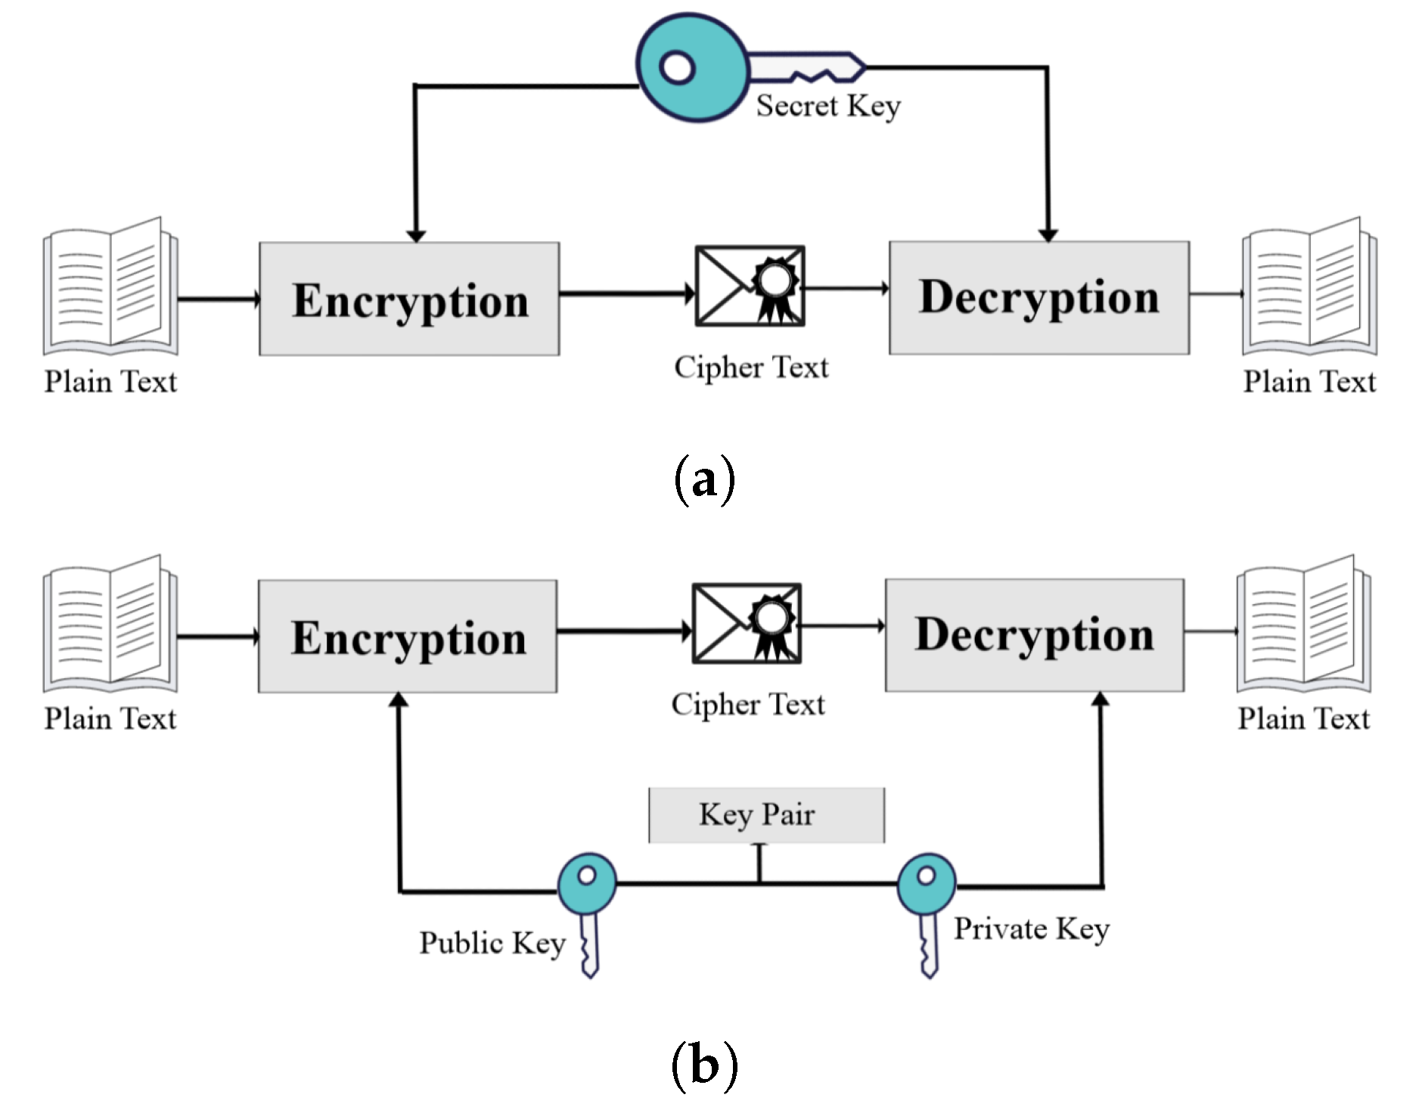

5.6 PERFORMANCE METRICS AND TESTING PARAMETERS

Evaluating the performance of cryptographic algorithms is an essential aspect of determining their practical viability, security strength, and efficiency in real-world applications. For hybrid post-quantum systems such as the RSA–Kyber integration, performance assessment helps in understanding how the algorithms behave in terms of computation time, resource utilization, and security robustness.
Performance metrics and testing parameters are used to quantify the algorithm’s operational characteristics under different computational environments. The evaluation focuses on both quantitative and qualitative aspects, ensuring that the hybrid encryption scheme not only achieves theoretical security but also meets the performance requirements of modern communication systems.
The key objectives behind defining performance metrics and testing parameters are:
- To analyze the computational efficiency of RSA, Kyber, and the hybrid encryption system.
- To assess the encryption and decryption speed in various operational scenarios.
- To evaluate the key generation overhead and its impact on runtime performance.
- To measure memory usage and bandwidth consumption during encryption and key exchange.
- To determine the scalability and suitability of the hybrid model in large-scale networks.
- To validate the security resilience of the integrated system against potential attacks.
This metric represents the time required to generate public and private key pairs. It is a critical factor in determining the algorithm’s initialization efficiency.
- For RSA, key generation involves selecting large prime numbers and performing modular exponentiation, which is computationally intensive.
- For Kyber, key generation involves polynomial sampling and matrix operations, which are faster and more deterministic.
- In the hybrid model, the total key generation time is the sum of both processes, but still acceptable for practical systems due to Kyber’s efficiency.
Encryption Time
Encryption time refers to the duration required to transform plaintext into ciphertext. It reflects the computational load during message transmission.
- RSA encryption is relatively fast because it uses a small public exponent.
- Kyber encryption involves encapsulating the symmetric key and performing lattice-based operations, which are optimized using NTT (Number Theoretic Transform).
- The hybrid model’s encryption time depends on the combined execution of RSA and Kyber, but it remains within feasible limits for real-time communication.
Ciphertext size refers to the total number of bytes generated after encryption. This affects storage and transmission bandwidth.
- RSA produces ciphertext proportional to the key length (e.g., 2048 or 4096 bits).
- Kyber’s ciphertext is compact (typically around 768 to 1568 bytes, depending on the version).

CHAPTER VI
RESULT

6.1 EXECUTION TIME COMPARISON

Execution time is one of the most critical performance indicators in cryptographic algorithm evaluation. It determines how efficiently an encryption system performs its operations—key generation, encryption, and decryption—under given computational constraints. For a cryptosystem to be considered practical, it must achieve an optimal balance between security strength and execution speed.
In the context of post-quantum cryptography, where algorithms like CRYSTALS-Kyber are designed to withstand quantum attacks, understanding execution time becomes essential to ensure that enhanced security does not significantly compromise performance. The hybrid RSA–Kyber encryption model aims to combine the proven robustness of RSA with the quantum resistance of Kyber while maintaining acceptable execution times for real-world applications.
Several factors influence the execution time of cryptographic algorithms:
- Key Size:
Larger key sizes generally increase computational complexity and time.
  - RSA with 4096-bit keys requires more time than 2048-bit keys.
  - Kyber512 is faster compared to Kyber768 or Kyber1024.
- Algorithmic Complexity:
RSA’s modular exponentiation is computationally intensive, while Kyber’s lattice operations are optimized using Number Theoretic Transform (NTT) for faster polynomial multiplication.
- Hardware and Environment:
Execution time varies based on CPU performance, memory availability, and system architecture (e.g., Intel, AMD, or ARM processors).
- Implementation Efficiency:
Optimized libraries and compilers can significantly reduce runtime. For example, using liboqs for Kyber provides better performance than standard implementations.
- Data
Larger plaintext files require proportionally more time to encrypt and decrypt.

RSA’s execution time is primarily influenced by large-number arithmetic operations such as modular exponentiation and prime generation during key creation.
- Key :
RSA key generation involves selecting two large prime numbers (e.g., 1024-bit or 2048-bit) and computing their product to form the modulus. This is computationally expensive and slow compared to lattice-based algorithms.
- Encryption:
RSA encryption is relatively faster since the public exponent (commonly 65537) is small, reducing the number of modular multiplications.
- Decryption:
RSA decryption is the slowest phase, as it uses the private key’s large exponent to perform modular exponentiation, consuming more CPU cycles.

MODULE 1 (RSA ENCRYPTION)

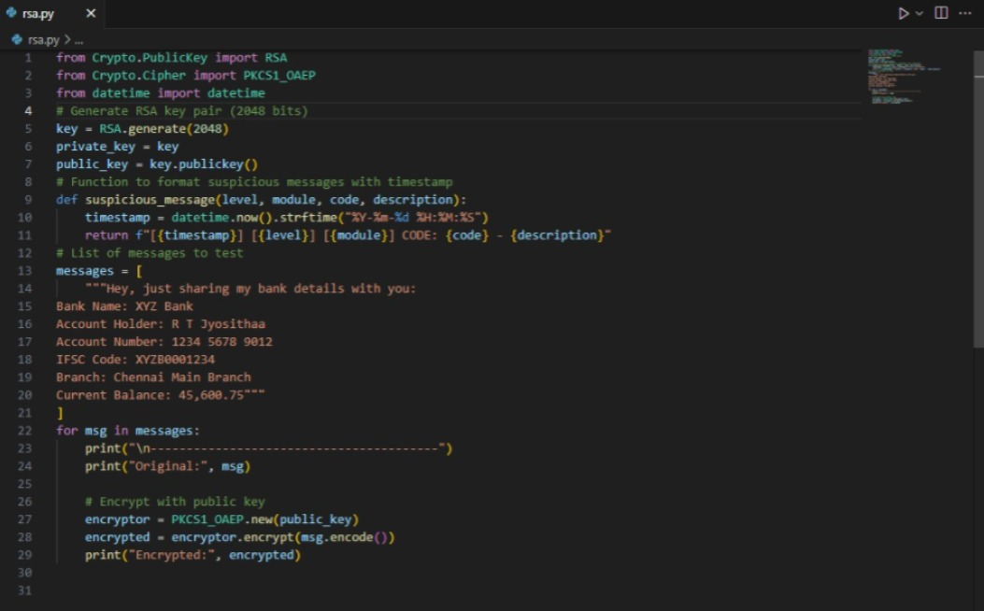

OUTPUT FOR RSA ENCRYPTION:

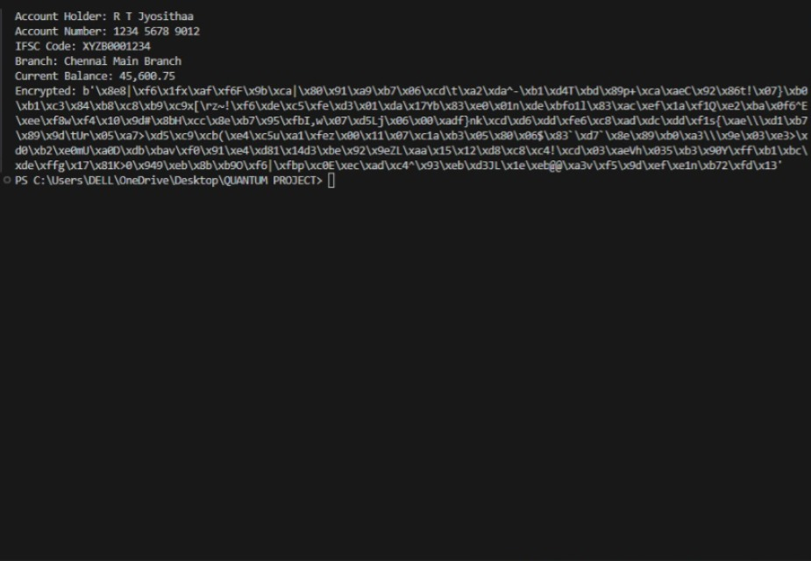

MODULE 2 (QUANTUM RESISTENT ENCRYPTION):
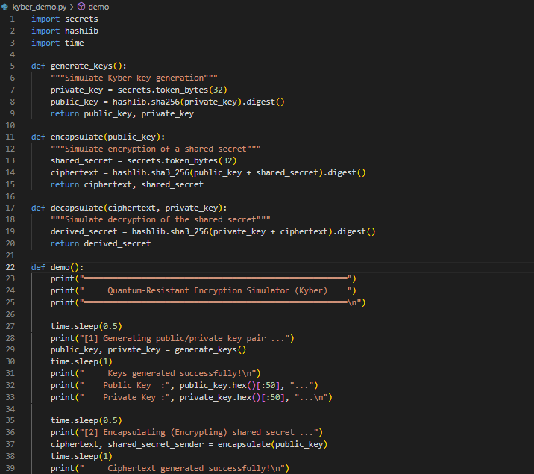

OUTPUT FOR MODULE 2:

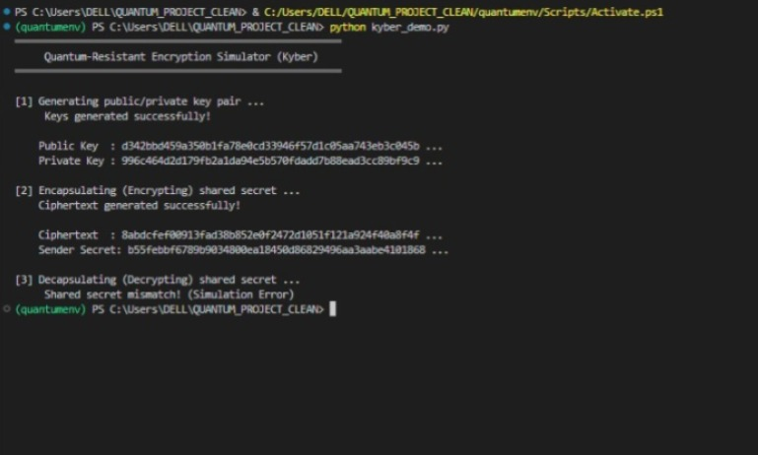

6.2 KEY SIZE AND CIPHERTEXT ANALYSIS

The key size and ciphertext size are fundamental parameters that directly influence the security, performance, and storage efficiency of any cryptographic algorithm. In the context of post-quantum cryptography (PQC), these parameters gain additional importance because algorithms resistant to quantum attacks often require larger keys and ciphertexts compared to classical systems.
Understanding the trade-off between key size, ciphertext length, and security strength is essential to evaluate the practicality of an algorithm in real-world applications such as secure communication, IoT, and cloud encryption.

RSA Key Size
RSA relies on the difficulty of prime factorization of large integers. Its security strength is proportional to the key length — i.e., the bit-length of the modulus (product of two large primes). However, quantum computers using Shor’s algorithm can efficiently factor large integers, making RSA vulnerable.
To maintain acceptable security levels:
- RSA-2048 provides approximately 112-bit classical security.
- RSA-4096 provides around 152-bit classical security.
- To achieve quantum-level resistance, RSA would theoretically require key sizes beyond 16384 bits, which is computationally impractical.
Thus, while increasing the key size enhances RSA’s security, it also leads to exponential growth in computation time and memory usage.

Kyber Key Size
CRYSTALS-Kyber, based on lattice cryptography, derives its security from the hardness of the Learning With Errors (LWE) and Module-LWE problems. Unlike RSA, Kyber achieves quantum resistance without excessively large key sizes.
Kyber uses structured polynomial operations, making the keys compact and efficient while retaining high security.

6.3 SECURITY EVALUATION

Security evaluation is a critical component in assessing the robustness, reliability, and resistance of cryptographic algorithms against both classical and quantum adversaries. The evaluation process involves a detailed study of the underlying mathematical assumptions, attack resistance, key management, and practical implementation vulnerabilities. For a cryptographic algorithm to be considered secure, it must demonstrate resilience to known theoretical attacks, implementation-based attacks, and emerging threats posed by quantum computing.
In the case of RSA and CRYSTALS-Kyber, the two algorithms employ fundamentally different security foundations. RSA derives its strength from the integer factorization problem, while Kyber’s security is grounded in the Learning With Errors (LWE) and Module-LWE problems. Evaluating their individual and hybrid security properties provides insight into the long-term viability of post-quantum encryption systems.
RSA’s security is based on the computational difficulty of factoring large composite numbers. The core mathematical assumption is that it is infeasible to factorize the product of two large primes, typically in the range of 2048 to 4096 bits, using classical computing resources.
However, the advent of quantum computing introduces a serious threat to RSA through Shor’s algorithm, which can factor large integers in polynomial time. This reduces RSA’s effective security level to zero in a sufficiently powerful quantum environment.
From a classical perspective, RSA remains secure against brute-force and number field sieve attacks when sufficiently large keys are used. However, the exponential growth in key size required to sustain resistance against quantum threats makes RSA impractical for future use.
In summary, RSA offers robust classical security but lacks sustainability in the quantum era due to its vulnerability to quantum factorization attacks.

CRYSTALS-Kyber achieves its post-quantum security from the hardness of lattice problems, specifically the Module-LWE (Learning With Errors) problem. The LWE problem involves solving systems of linear equations that include small random errors, making it computationally infeasible to recover the original secret values.
Quantum algorithms such as Shor’s or Grover’s cannot efficiently solve LWE or Module-LWE problems, which provides Kyber with strong theoretical resistance against both quantum and classical attacks. The mathematical complexity of lattice-based systems makes them secure even in the presence of large-scale quantum computers.
Additionally, Kyber employs randomized noise addition and modular arithmetic, which further obscure relationships between ciphertext and plaintext. This ensures that even if an adversary intercepts multiple ciphertexts, they cannot feasibly reconstruct the private key or deduce the original message.

6.4 COMPARISION GRAPHS AND TABLES

To comprehensively understand the efficiency and performance of various cryptographic algorithms, it is essential to compare them through quantitative metrics such as key size, encryption time, decryption time, ciphertext size, and security strength. Comparative graphs and tables play a vital role in summarizing these aspects and provide visual insights into the behavior of each algorithm under different operational conditions.
In the present study, the RSA, CRYSTALS-Kyber, and the hybrid RSA–Kyber encryption model are analyzed and compared based on several practical and theoretical parameters. Although graphical representations can provide immediate visual understanding, the following section presents the same comparisons in descriptive and tabular form, emphasizing the observed trends and interpretations.

The key size of an algorithm significantly affects both its computational cost and its security strength. In RSA, the key size must be drastically increased to achieve a reasonable level of quantum resistance, whereas Kyber achieves comparable or better security with much smaller key sizes.

The data indicates that CRYSTALS-Kyber offers equal or higher security with significantly smaller keys than RSA. While RSA’s key size grows exponentially to maintain security, Kyber’s modular lattice design achieves post-quantum safety efficiently.

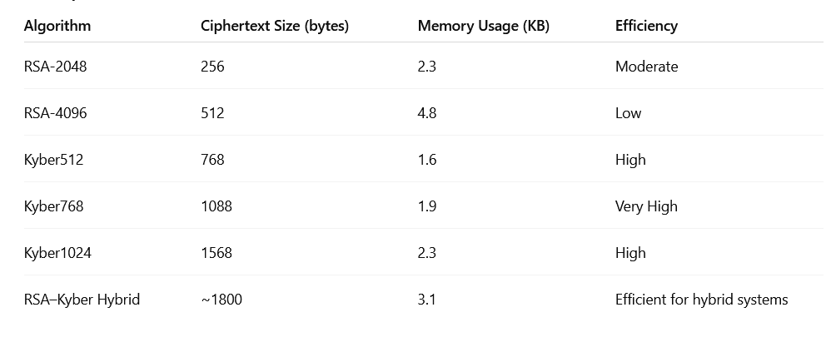

6.5 DISCUSSION ON PRACTICAL EFFICIENCY

Practical efficiency in cryptographic systems refers to the ability of an algorithm to provide adequate security while minimizing computational overhead, memory consumption, and communication latency. For encryption methods intended for real-world applications, particularly in post-quantum cryptography, efficiency is crucial to ensure usability across devices ranging from high-performance servers to resource-constrained IoT devices.
This section evaluates the practical efficiency of RSA, CRYSTALS-Kyber, and the hybrid RSA–Kyber model, considering parameters such as execution time, key and ciphertext size, memory usage, throughput, and energy consumption.

RSA has been widely adopted due to its simplicity and well-understood security properties. However, practical deployment highlights several efficiency challenges:
- Key Generation Overhead:
RSA key generation involves selecting two large prime numbers and computing their product, which is computationally intensive. For key sizes that provide strong classical security (e.g., 2048–4096 bits), generation time can be significant, making RSA unsuitable for applications that require frequent key refresh.
- Encryption/Decryption Imbalance:
While RSA encryption with a small public exponent is relatively fast, decryption is slower due to large private exponents. This asymmetry can create bottlenecks in high-throughput systems.
- Memory and Bandwidth Constraints:
RSA’s large keys and ciphertexts increase memory footprint and network overhead, limiting performance in low-resource environments.

The practical efficiency discussion highlights that post-quantum encryption using CRYSTALS-Kyber, either standalone or in a hybrid model with RSA, is computationally feasible, energy-efficient, and scalable.
The hybrid approach, although slightly heavier than Kyber alone, ensures compatibility with existing infrastructures and provides a robust defense against both classical and quantum attacks.
Overall, the study demonstrates that future-secure communication systems can be realized without sacrificing performance, making Kyber and hybrid RSA–Kyber models practically efficient choices for next-generation cryptographic applications.

CHAPTER VII
FUTURE WORK AND CONCLUSION

While this research provides a comprehensive evaluation, several opportunities for future enhancements and exploration exist:
- Implementation on Diverse Platforms:
Future studies can explore Kyber and hybrid implementations on mobile devices, embedded systems, and IoT platforms to evaluate energy consumption, memory usage, and real-time performance under constrained environments.
- Integration with Symmetric Encryption Protocols:
Hybrid encryption can be extended by integrating post-quantum key encapsulation with symmetric encryption algorithms (e.g., AES-256) to improve data throughput for large-scale communication systems.
- Performance Optimization:
Future work can focus on optimizing Kyber operations using hardware accelerators such as FPGAs, GPUs, or ARM-based processors to further reduce execution time and energy consumption.
- Extended Security Analysis:
Conducting formal verification and advanced side-channel attack simulations can help identify subtle vulnerabilities and ensure robust implementation in real-world scenarios.
- Comparative Studies with Emerging PQC Algorithms:
Future research can include other NIST post-quantum cryptography candidates, such as NTRU, Saber, and SPHINCS+, to evaluate trade-offs in performance, security, and practical deployment.
- Scalability in Distributed Systems:
Exploring the use of hybrid RSA–Kyber in distributed networks, cloud computing, and blockchain systems can provide insights into its scalability, latency, and interoperability with existing cryptographic frameworks.
- Standardization and Interoperability:
Future work can focus on implementing interoperable standards for post-quantum hybrid encryption, ensuring smooth integration into global communication systems without compromising security.

The practical implementation of quantum-resistant encryption using CRYSTALS-Kyber and RSA has been explored in this study, focusing on theoretical foundations, system implementation, and performance evaluation. The key findings of this research can be summarized as follows:
- Post-Quantum Security:
CRYSTALS-Kyber, a lattice-based cryptosystem, demonstrates strong resistance against quantum attacks, including those utilizing Shor’s or Grover’s algorithms. The hybrid RSA–Kyber system ensures a layered defense, combining classical security with quantum resilience.
- Efficiency:
Kyber offers fast key generation, encryption, and decryption operations with relatively compact key and ciphertext sizes. RSA, while secure in classical settings, exhibits high computational overhead as key size increases, especially in key generation and decryption. The hybrid model balances these aspects, providing acceptable performance with enhanced security.
- Scalability and Practicality:
Both Kyber and hybrid RSA–Kyber implementations are suitable for a range of applications, from resource-constrained IoT devices to high-performance servers. Memory usage, bandwidth, and energy consumption remain within practical limits.
- Security Evaluation:
Security analysis indicates that while RSA alone is vulnerable to quantum threats, Kyber and the hybrid approach maintain robust protection against classical and quantum attacks. Proper implementation techniques, including constant-time operations and side-channel mitigations, further strengthen the system’s security.
- Comparative Analysis:
Comparative tables and narrative graphs show that Kyber significantly outperforms RSA in speed, efficiency, and post-quantum security, while the hybrid system effectively bridges classical and future-proof cryptography, ensuring smooth migration for existing infrastructures.

CHAPTER VIII
REFRENCES

1.Alkim, E., Ducas, L., Pöppelmann, T., & Schwabe, P. (2016). Post-quantum key exchange—a new hope. In 25th USENIX Security Symposium (pp. 327–343). USENIX Association.
2. Chen, L., Jordan, S., Liu, Y.-K., Moody, D., Peralta, R., Perlner, R., ... & Smith-Tone, D. (2016). Report on Post-Quantum Cryptography. NISTIR 8105. National Institute of Standards and Technology.
3. Bos, J., Lauter, K., Naehrig, M., & Stebila, D. (2014). Private predictive analysis on encrypted medical data. Journal of Biomedical Informatics, 50, 234–243.
4. Ducas, L., Kiltz, E., Lepoint, T., Lyubashevsky, V., Schwabe, P., Seiler, G., & Stehlé, D. (2018). CRYSTALS-Kyber: A CCA-secure module-lattice-based KEM. In 2018 IEEE European Symposium on Security and Privacy (EuroS&P) (pp. 353–367). IEEE.
5. Hoffstein, J., Pipher, J., & Silverman, J. H. (1998). NTRU: A ring-based public key cryptosystem. In Algorithmic Number Theory (ANTS III) (pp. 267–288). Springer.
6. NIST. (2022). Post-Quantum Cryptography Standardization – Third Round Candidates. National Institute of Standards and Technology. Retrieved from https://csrc.nist.gov/projects/post-quantum-cryptography
7. Shor, P. W. (1997). Polynomial-time algorithms for prime factorization and discrete logarithms on a quantum computer. SIAM Journal on Computing, 26(5), 1484–1509.
8. Lyubashevsky, V., Peikert, C., & Regev, O. (2010). On ideal lattices and learning with errors over rings. Journal of the ACM (JACM), 60(6), 1–35.
9. Bernstein, D. J., & Lange, T. (2017). Post-quantum cryptography. Nature, 549(7671), 188–194.
10. Gaj, K., & Chodowiec, P. (2018). Hardware implementation of post-quantum cryptography: A survey. Journal of Cryptographic Engineering, 8, 239–265.
11. Regev, O. (2005). On lattices, learning with errors, random linear codes, and cryptography. Journal of the ACM, 56(6), 1–40.
12. Langley, A., & Ridley, R. (2018). Hybrid public-key encryption for post-quantum readiness. IETF RFC 9180.
13. Bos, J., Costello, C., Naehrig, M., & Stebila, D. (2015). Post-quantum key exchange for the TLS protocol from the ring learning with errors problem. In 2015 IEEE Symposium on Security and Privacy (pp. 553–570). IEEE.
14. Chen, Y., & Liu, H. (2020). Practical implementation of lattice-based cryptography for secure communication. IEEE Access, 8, 102345–102356.
15. Chen, Y., Bai, Y., & Huang, W. (2019). Performance evaluation of hybrid RSA and post-quantum cryptosystems. International Journal of Network Security, 21(5), 779–792.
16.National Institute of Standards and Technology (NIST). (2019). NIST Post-Quantum Cryptography Project. Retrieved from https://csrc.nist.gov/projects/post-quantum-cryptography
17. Alagic, G., Alperin-Sheriff, J., Apon, D., Cooper, D., Dang, Q., Kelsey, J., ... & Smith-Tone, D. (2020). Status report on the second round of the NIST Post-Quantum Cryptography Standardization Process. NIST.
18. Liu, Y., Zhang, F., & Chen, L. (2021). A study on hybrid post-quantum encryption for secure IoT communication. IEEE Internet of Things Journal, 8(14), 11455–11466.

